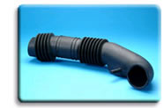
  Thermoplastic Elastomers
  Nomenclature

Individual grades of our thermoplastic elastomers are designated with a product name that identifies the brand name, the technology used in the material, the market for which it is intended, and its Shore hardness and scale. The following product name will serve as an example of this nomenclature protocol:

The Brand Name indicates that this is a NexPrene TPE product
The first digit of the grade number indicates the technology employed in the product:
‘1’ in this position identifies this as dynamically vulcanized using a conventional cure
‘9’ would indicate the material uses our proprietary free-radical cure technology
The second digit identifies the intended market for the product.
The 4-digit code ends with the Shore hardness and the scale on which it is measured:
‘67A’ in this example indicates a material with a hardness of 67 Shore A

